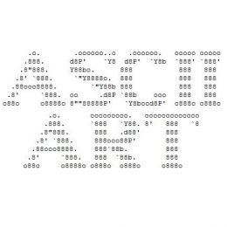**CSE 1284 Lab 1 ASCII Art   
Mrs. JK’s sections Fall 2018**

**Objectives**

* practice designing before coding
* introduce the print() function, Chapter 2
* introduce code comments
* introduce the IDLE python editor
* learn to take screenshots
* introduce the lab report format

**Problem Statement**

In this lab assignment, you will be writing programs that will display 3 different pictures on the screen. Each picture is “drawn” by using a combination of characters found on your keyboard and whitespace (spaces and newlines). Each picture should have at least 20 characters (not counting whitespace) but you will probably want more. You must use at least three different characters in each picture. Below are two examples of what a finished picture might look like when displayed on your computer screen.

**__( ) ________ __  
 _/ o \/ \ /** Mr. Squeaky the mouse **\*____ / \ ___/   
 \ |______| \  
 \ | \ |  
 /\// /\/_/**

**\*\*\*\*\*\*\*\*\*\*\*\*\*\*\*\*\*\*\*\*\*\*\*\*\*\*\*\*** These are the initials L H

**\* |===| |===| |===| \*** Lisa Henderson had the idea for this lab

**\* | | | | | | \***

**\* | | | |____| | \***

**\* | | | | | | \***

**\* | | | | | | \***

**\* |======| |===| |===| \***

**\*\*\*\*\*\*\*\*\*\*\*\*\*\*\*\*\*\*\*\*\*\*\*\*\*\*\*\*** [Table of ASCII characters](http://www.lookuptables.com/)

You don’t have to get this fancy, but how cool is this?

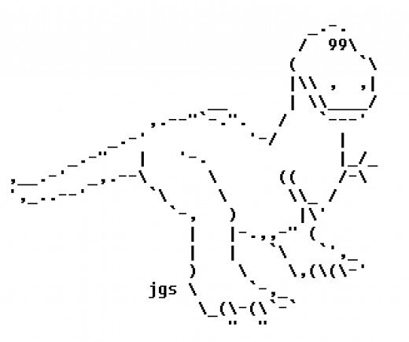

Even fancier! Bit more involved than what you need to do but shows what’s possible!

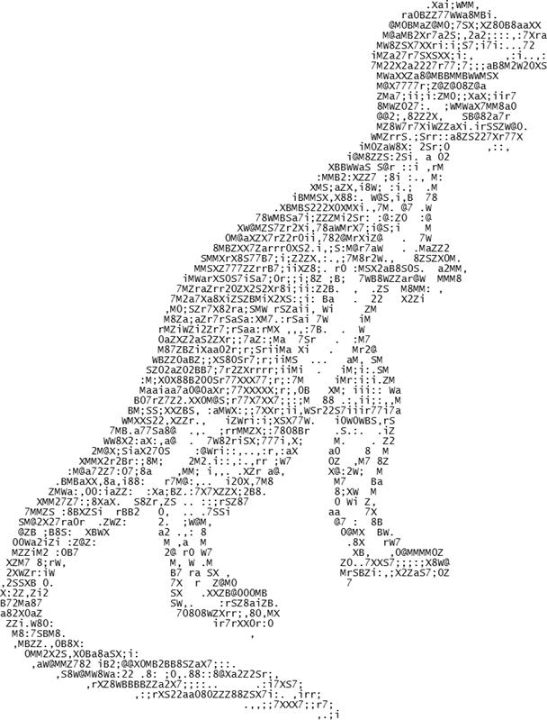

Required Drawings

Your program must draw three pictures. Write one code segment per picture.  
Here are the pictures that you are required to draw:

* Your own age (don’t just print the numbers 18, draw them large using ASCII art)  
  You must have a border around your age. Make it as fancy as you wish.
* A favorite toy or object from your childhood (slide, inline skate, playdoh)
* An air, sea, or amphibious vehicle (boat, airplane, rocket, hovercraft, hang glider)

**Design**

For the design of this program, find some graph paper or draw a grid on a sheet of paper with a pen and lay out your “picture” with a pencil. That way you will know where the whitespaces are and where the letters/symbols should go. Using a pen for the grid and pencil for the characters makes modifying your picture easier during the design phase. Draw your design neatly! Take a photo of each picture design with your phone.

You must include a photo of your design in the lab report. Be sure the design is clearly visible!

**You may not code a picture until the TA sees your design for it.**

Here is an example of a design, written in purple pen for good visibility. (Do initial designs in pencil)

HONORS: See special instructions about the extended character set (near the end of this document)

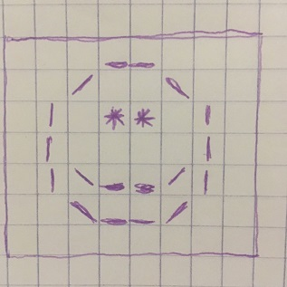

**Implementation and Testing**

Write three python code segments to draw your pictures. Find code examples and IDLE instructions in Chapter 2. Here is what the code for our smiley face looks like. Note that it has a comment. Yours should too.

# Display a smiley face! see design 1 **🡨 this is a comment**

print( " __ " )

print( " / \ " )

print( " | ** | " )

print( " | | " )

print( " |\__/| " )

print( " \__/ " )

print( " " )

You will write your code in the IDLE editor. When your program runs, you will take screenshots of the output (your pictures), and put the screenshots in your lab report.

Did the printed pictures turn out as you expected? If not, you may need to modify your design!  
Or perhaps there was an error, known as a bug, in your code. Fix it.

**Executions Screenshots**

Throughout the semester, you will need to take screenshots of your programs output for your lab reports.  
For lab 1, we need to clearly see your picture. It should be large and easy to see!

This is NOT acceptable. The smiley face picture is too small to see easily.

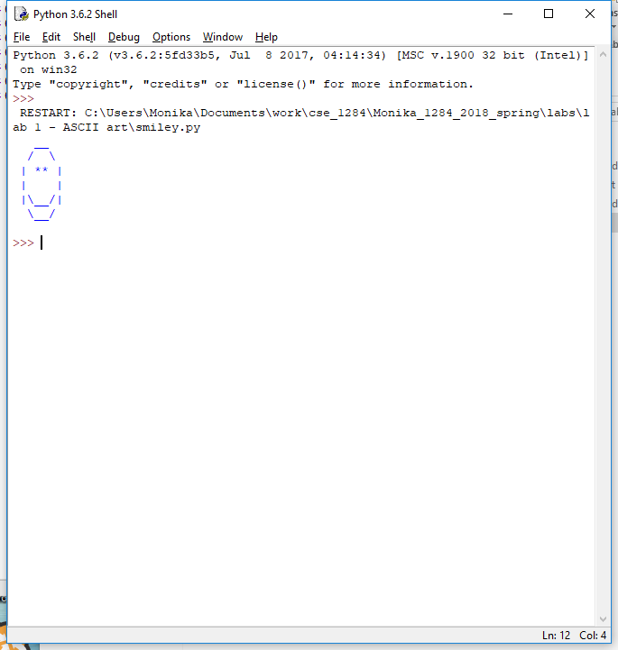

This is better and is acceptable but just barely.

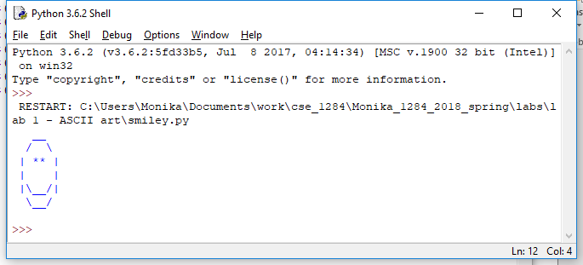

This is much better. You can paste screenshots into Windows Paint and crop them before pasting into Word.



**Lab Report**

For this lab only, you will be given a lab report template file you can start from. It contains all the lab report section required for lab 1. You will not need any additional sections. Further lab 1 instructions are provided   
in the lab 1 lab report template!

* Problem Statement
* Program Design
* Testing
* Execution Screenshots
* Analysis and Conclusions
* References
* Code Appendix

**Honors Instructions – Extended Character Set**

You are required to use some characters from the extended ASCII table.  
To see what they might look like, click the link and scroll to Extended ASCII Codes.

<http://www.lookuptables.com/>

Your computer might have different symbols than the ones shown. In your design diagram,   
highlight the extended characters in yellow so the grader can easily find them.  
  
What happens if you try print( chr(187) )   
Also try 168, 171, 176, 215. Maybe some others too! Find a few you like.  
  
print( "abc", chr(187), "xyz", sep="" )

**Deliverables**

You must turn in both your program file (*.py) and your lab report (*.pdf)  
The files must be named as shown below.

Your lab report must be a PDF file. You can’t just add .pdf to the end of a Word document!  
In Word, do Save As then select PDF from the file type dropdown menu.  
  
Lab1_LabSectionNUM_GroupNUM_NETID1_NETID2_program.py  
Lab1_LabSectionNUM_GroupNUM_NETID1_NETID2_report.pdf

Turn in work on mycourses. Only work turned in on mycourses will be graded.

**Do not complain to the instructor that your lab partner didn’t turn the lab in.  
Both lab partners are responsible for turning labs in on time.  
Verify that your lab partner turned it in on time or turn it in yourself.**

**Do not complain to the instructor that your partner had all the files.  
Both lab partners must have all code and the entire lab report.**